Assignment 5

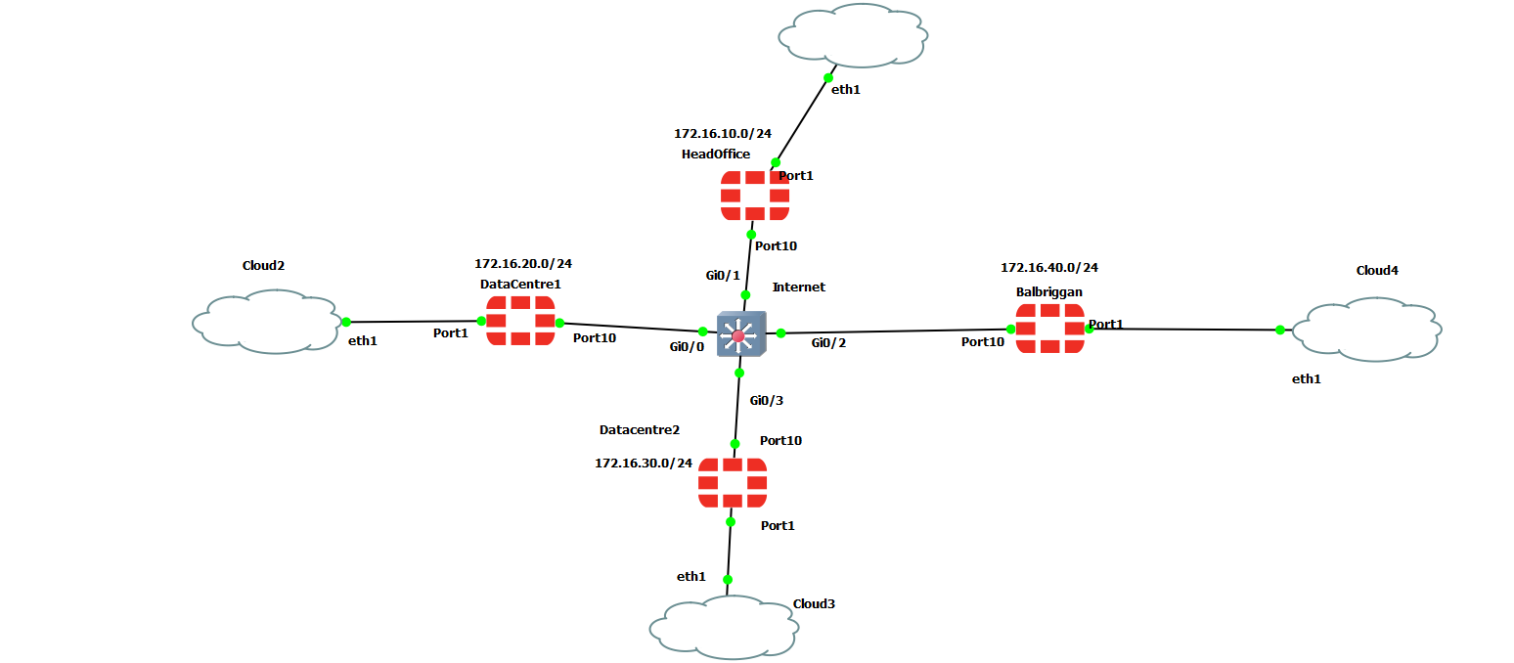
Diagram and Notes

This is the configuration for the electric-petrol site on the WAN interface. The Balbriggan site connects to the headoffice and two datacentres over the internet using an IPSEC VPN. Four internet-facing firewalls obtaining DHCP addresses (can also be static by changing the mode to static and excluding the address in the dhcp address pool) from the internet, which in this example is a layer 3 switch.
The DHCP addressing scheme for this example splits each site into different VLANs. For the purposes of this demonstration I’m using the network subnet 172.16.0.0 where the third octet is changed to denote different vlans.
- HeadOffice has the VLAN subnet 172.16.10.0/24. It is VLAN 10.
- DataCentre1 has the VLAN subnet 172.16.20.0/24. It is VLAN 20.
- DataCentre2 has the VLAN subnet 172.16.30.0/24. It is VLAN 30.
- Balbriggan has the VLAN subnet 172.16.40.0/24. It is VLAN 40.
- There is a Native VLAN of 999 configured on the switch.
- There is a Discard VLAN of 1000 configured on the switch. This is where all the unused ports on the switch are found.

OSPF is also used in this network to allow the “Internet” to see each firewall as neighbours. It is configured in area 0 but if you wanted to increase security you would change to area 0,1,2 and 3, depending on the configuration you wish. Below is an image showing the different ospf configurations on each firewall to allow visibility on the “Internet” switch. The Diffs are also provided in a text file in this project.

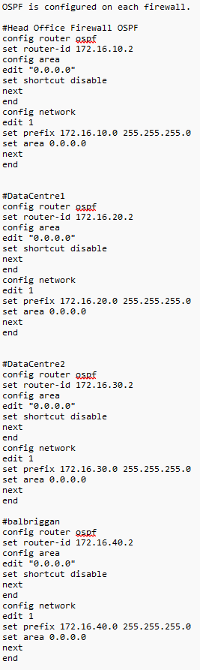
The IPSEC VPNs were configured after port1 on each firewall was connected to a bridged/internal adapter which allowed connection to the physical host. The GUI interface was used when setting up the IPSEC VPNS due to user-friendliness. Below is an example of Datacentre1 connecting to each site using an IPSEC VPN. I have also provided the phase2-interface code on the headoffice config which I used as an example for the VPN configuration.
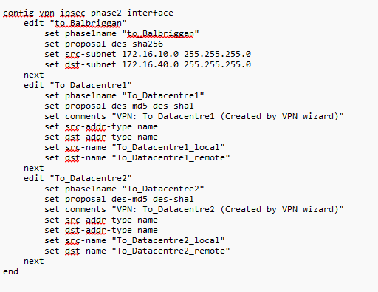

Datacentre1 to Datacentre2
Note that the network ip address is the address of the datacentre2 firewall (172.16.30.2). The Pre-shared key also needs to be common between both firewalls (in this case for demonstration purposes it is my student number). Port10 is also used as the outgoing interface because that is the “Internet-Facing” port.
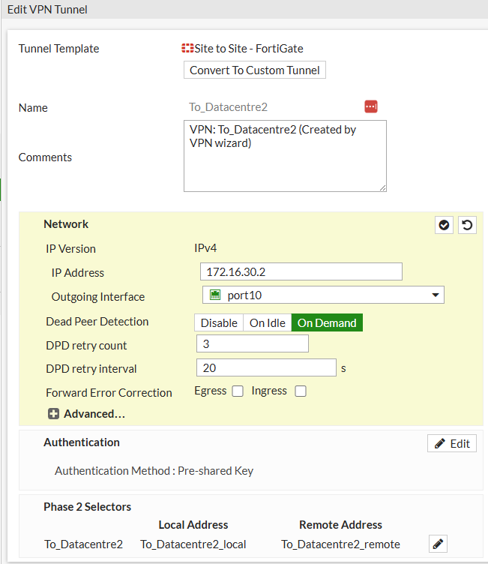

DataCentre1 to HeadOffice
Note that the network ip address is the address of the HeadOffice firewall (172.16.10.2). The Pre-shared key also needs to be common between both firewalls (in this case for demonstration purposes it is my student number). Port10 is also used as the outgoing interface because that is the “Internet-Facing” port.
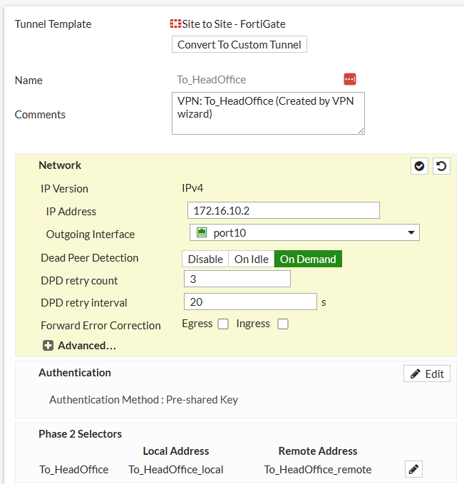

DataCentre1 to Balbriggan
I configured Datacentre1 to Balbriggan slightly differently. I used a custom vpn instead of site-to-site but they still have the same end result.
This vpn uses a remote static ip address (Balbriggans firewall IP address). It uses port10 as the internet-facing interface. It uses a pre-determined pre-shared key (again, this is just the student number of the student for demonstration purposes). For phase1 it uses Algorithm DES-SHA256 (AES128-SHA256 wasn’t available). And for its phase 2 it is using the local address (in this case datacentre1 is 172.16.20.0/24 and the remote address is 172.16.40.0/24). This type of vpn is more flexible than the typical site to site as it allows for more configuration options.
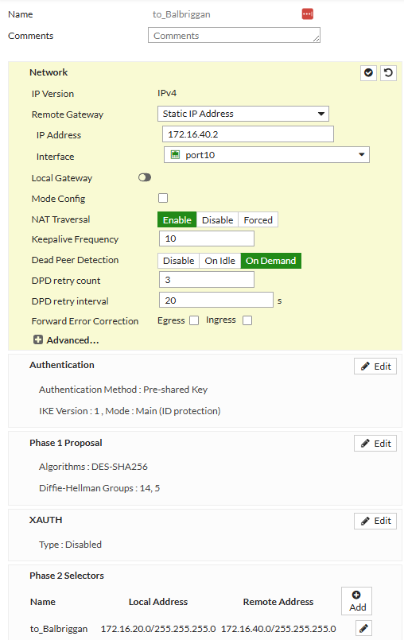

How do remote staff access applications?
Mobile staff would use an IPSEC VPN application such as Forticlient VPN. This is a free (or paid, whatever your preference is) that can be used as a viable solution for mobile users to connect to the different sites. They can use this client to access remote databases (say from Balbriggan to Datacentre1). Configuration of this client is required though which can be done by the IT department.
In the case of Forticlient you would add a new vpns connection and add the public ip address of the network you want (in this case going from Balbriggan to Datacentre1, the remote gateway would be 172.16.20.2). The port is usually the default (Forticlient uses port 500 for IPSEC VPNS). The Authentication method used in the client would be the pre-shared key specified earlier (in this example the student number would be used).
With this configuration on a mobile staff members device, they would be able to connect to the different sites without needing to physically be on them.

An explanation of how maintenance contractors might access their systems
The maintenance contractors would access their own systems (say if they’re not employees of electric-petrol, but contracted by electric-petrol), by having the VPN configured and, after correct vetting and confirmation of the integrity of the contactors infrastructure, would an IPSEC VPN tunnel then be set up between the electric-petrol sites and the contractors own sites. For example, say if a contractors site is 192.168.0.0/24, a VPN tunnel would need to be set up from the site that they wish to connect to (for example Datacentre1 which is 172.16.20.0/24). Once that is established and a pre-shared key/authentication method is configured, then the maintenance contractors would be able to access their own site along with the electric-petrol datacentre1.

An explanation as to how Internet access will work
Internet access would work by denying all traffic initially and then allowing or whitelisting the correct ports that are needed. For example, IPSEC for forticlient uses port 500. This port would need to explicitly be allowed for the vpn to work.
HTTPs which is port 443 would also need to be whitelisted to allow internet browser access. HTTP would be blocked depending on its needs and use cases. HTTP is unencrypted traffic, which could prove vulnerable to system attacks.

Ports are whitelisted (or blacklisted) on the fortigate firewalls by going to “Policy and Objects” and then “Firewall Policy”. You would create a new policy and enter in features like the incoming and outgoing interfaces, the sources and destinations as well as the requirements below.
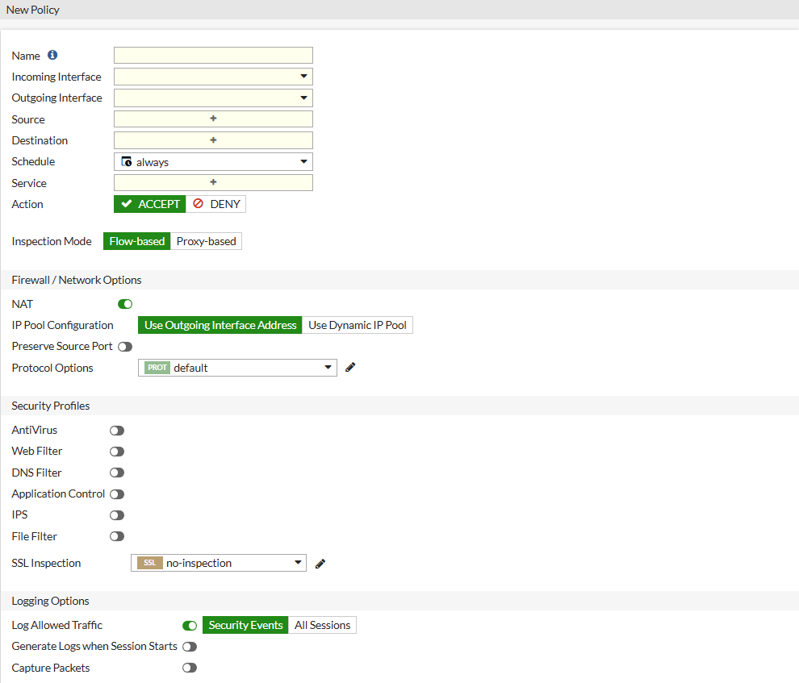

Demonstrate a site-to-site IPSEC VPN tunnel
The image below shows a VPN tunnel set up using the steps provided above (See Datacentre1 to Balbriggan for reference in the Diagram and Notes section). I go to the path VPN < IPSEC Tunnels < to_Balbriggan < Status. I right click “Bring up” and select “all phase 2 selectors”. My result is the green up status in the next image. I also replicated this for the other sites. This means that the datacentre1 is configured to have VPNs between each site. If there was a misconfiguration between any site it wouldn’t have come up on Datacentre1. This means that the tunnel can be brought up from the other three sites.

Configuring dhcp on the firewalls for the client PCs
I also configured DHCP for devices behind the firewalls (I.e port2 to simulate a pc). I went onto the firewall and went to this path “Network < Interfaces < port 2. For Balbriggan I entered the below information with 10.32.0.1 being the site subnet. Note that DHCP is on for this port. The pc could also be a router but for this demonstration we will use a PC.
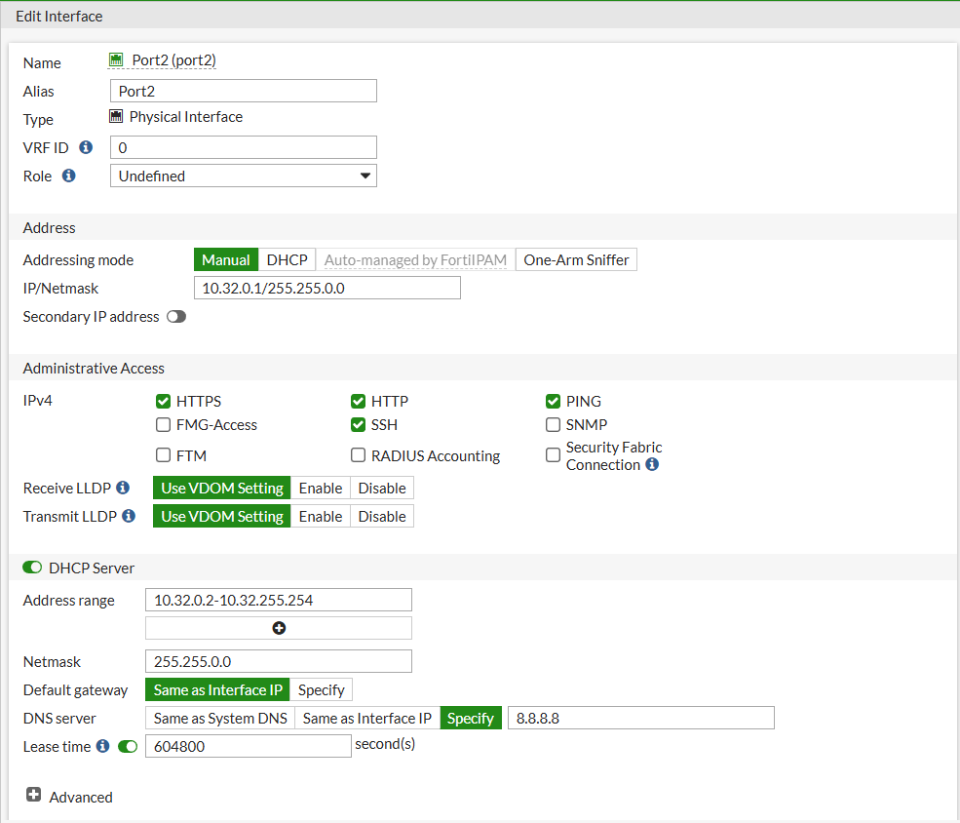

Here is Datacentre1
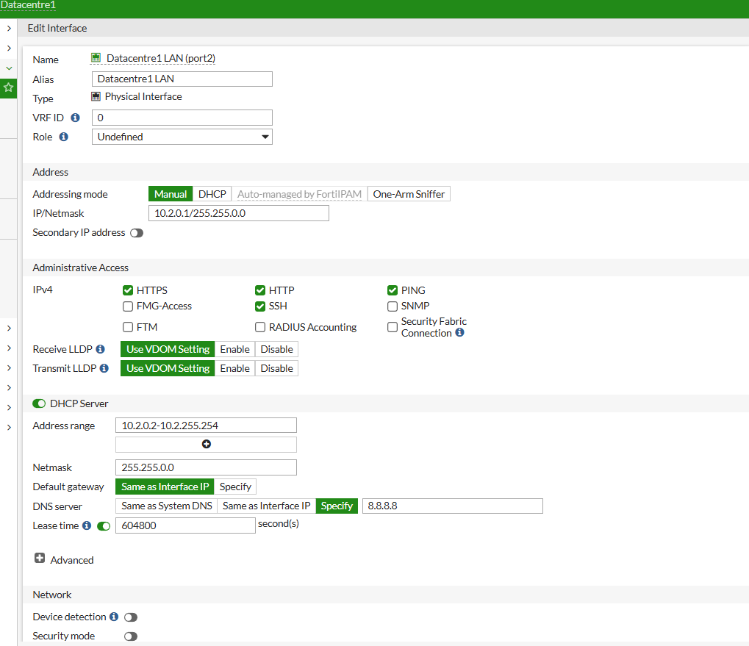

Creating Static Routes to allow communication between end devices.
I didn’t get the two dhcp pcs to send packets to each other due to a configuration issue, however this was my static routes (found in Network < Static Routes) to show the lan of Datacentre1 (10.2.0.0/16) to the lan of Balbriggan (10.32.0.0/16). I also put something similar to this configuration to the balbriggan firewall but made the policy specific to that lan.
